**Steps to Donate online without a PayPal account**

1. Go to [Donate](https://tcfnoshore-boston.org/donate.aspx) page or [Love Notes](https://tcfnoshore-boston.org/love-notes.aspx) page or [Website Sponsors](https://tcfnoshore-boston.org/website-sponsors.aspx) page
2. Scroll down to **GENERAL DONATION FORM** (or the **LOVE NOTES FORM** or the **WEBSITE** **SPONSOR FORM**)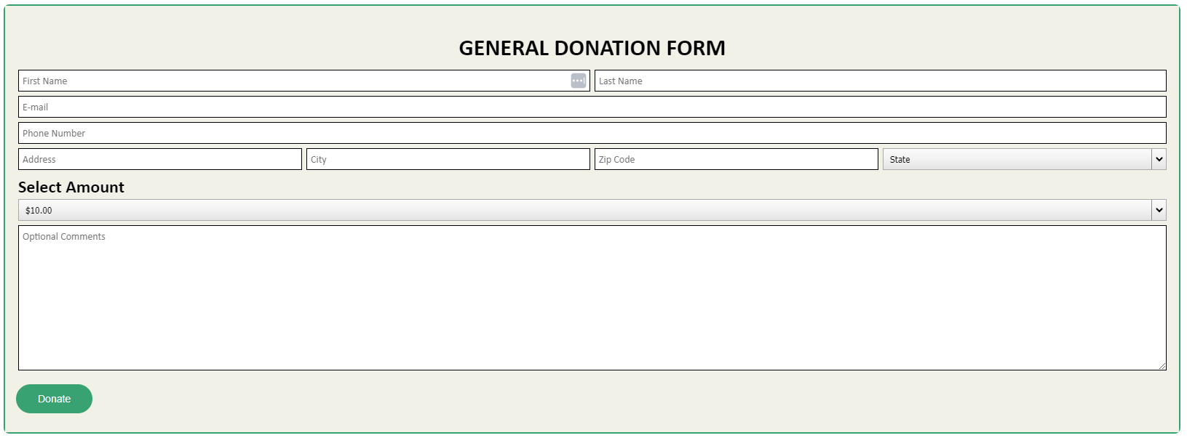
3. Fill out form (Select Amount to donate from drop-down list) > Click ‘Donate’ button  
   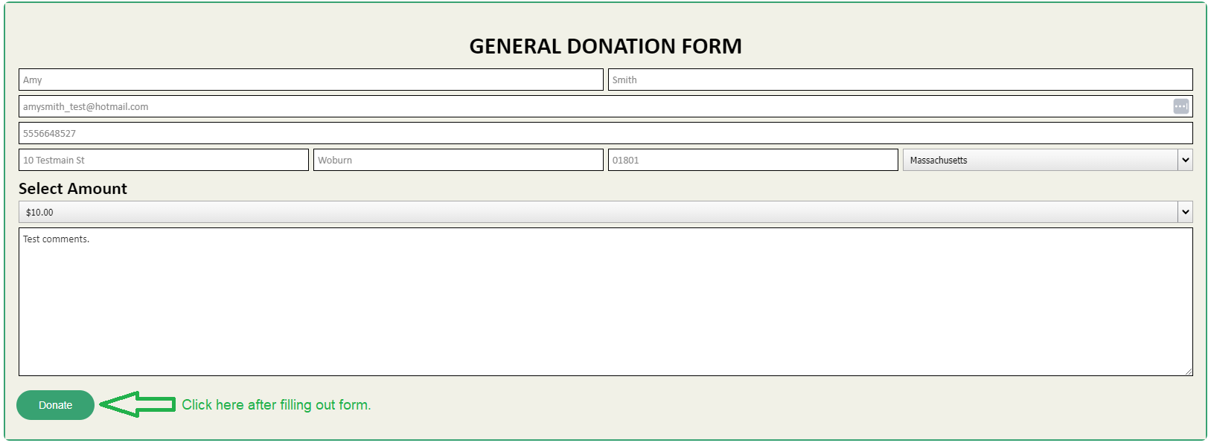
4. Icon will spin until next page is loaded  
   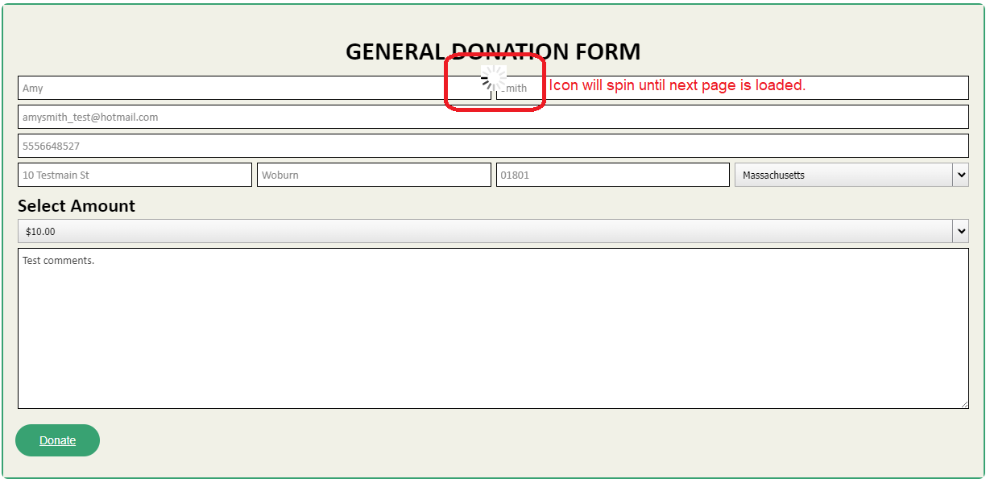
5. ‘Pay with PayPal’ page loads.  
   *Note: If you do not have a PayPal account, click ‘Pay with Debit or Credit Card’ button  
   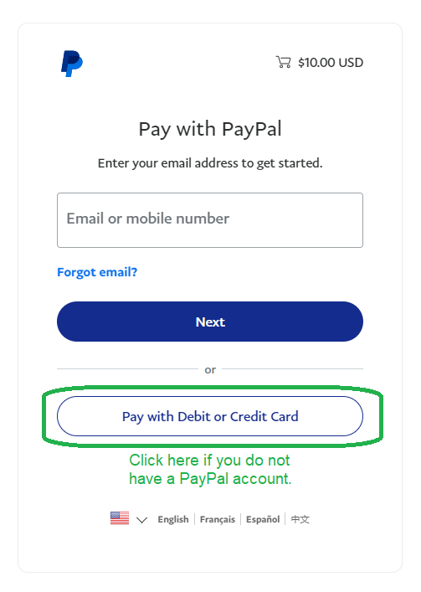
6. ‘Check out as a guest’ page loads.  
   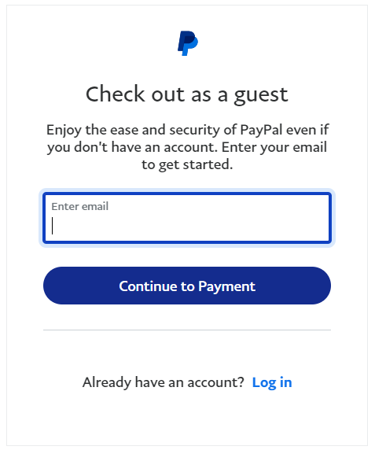
7. Enter email address > Click ‘Continue to Payment’ button  
   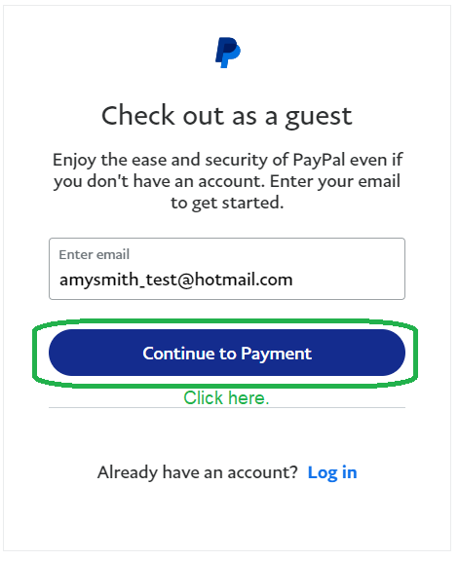
8. Fill out form  
   *If you don’t want to create a PayPal account, scroll down until you see the ‘**Save info & create PayPal account’** toggle switch (it’s circled in red below). Click the switch to disable it as it is enabled by default.  
   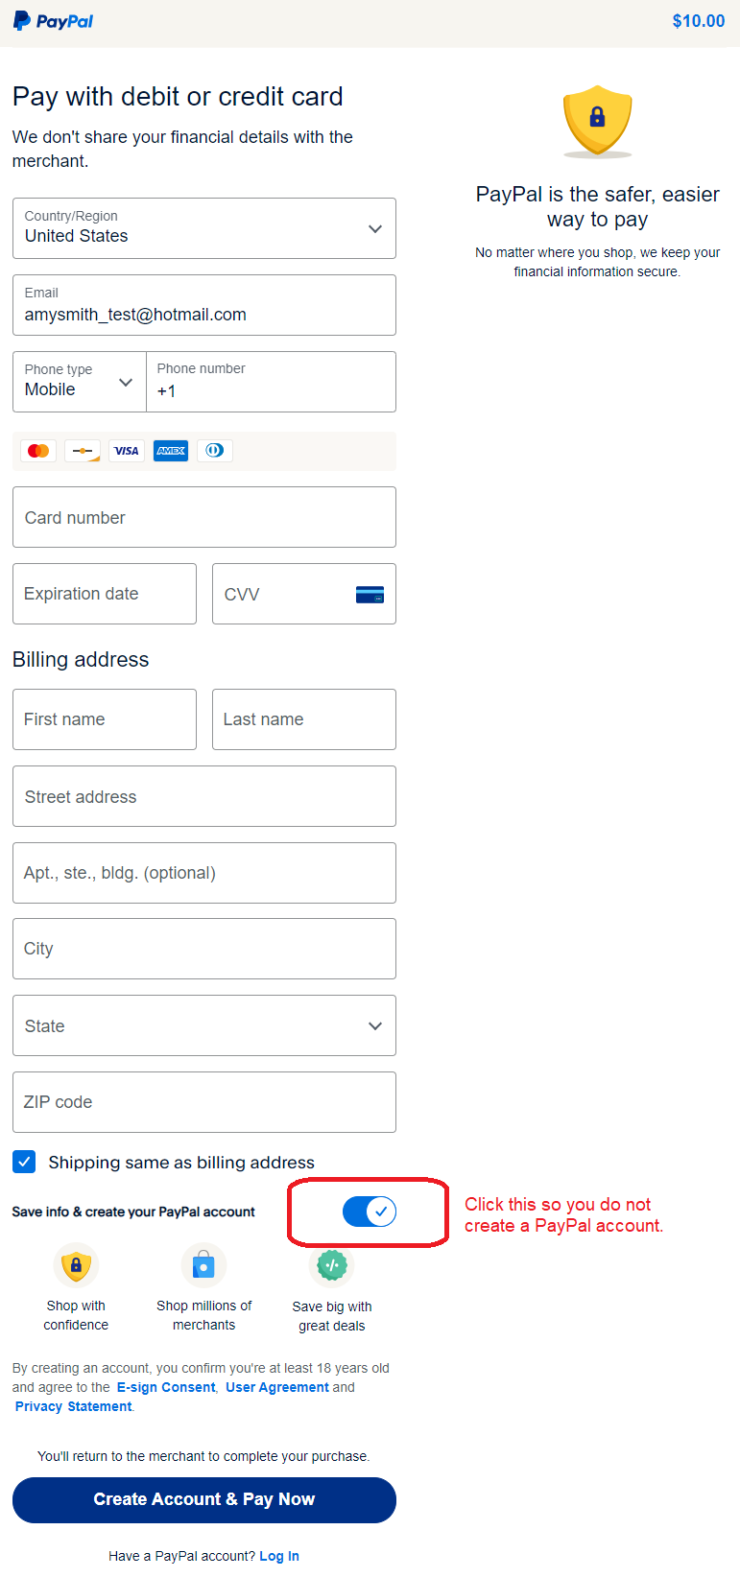
9. Click ‘Pay now as guest’ button  
   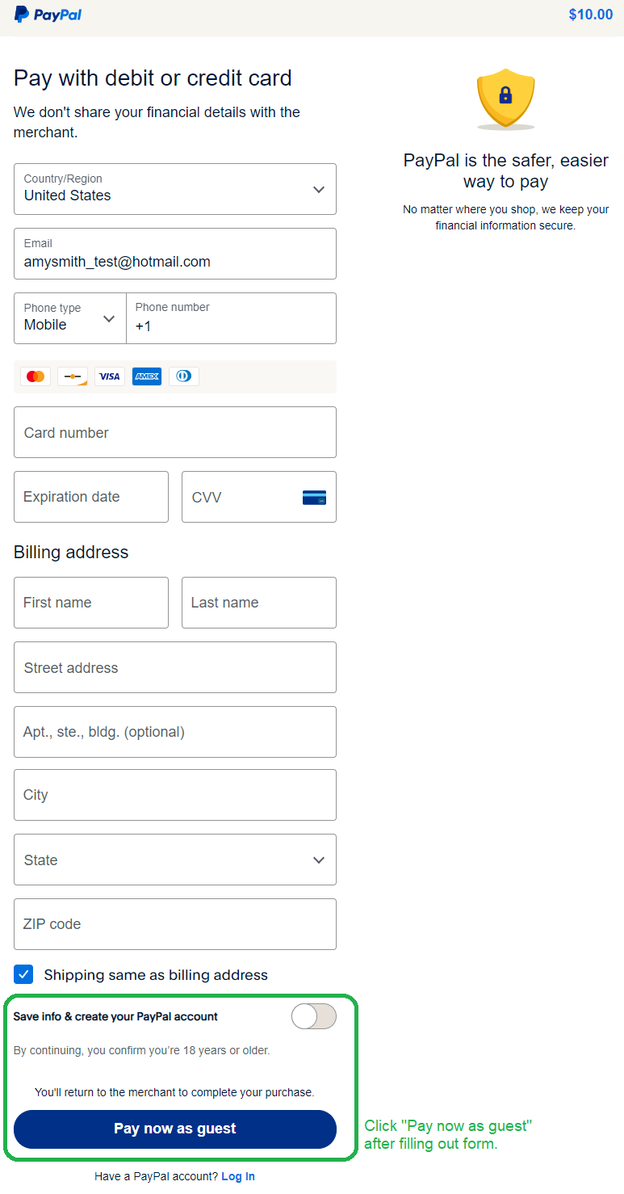
10. Once payment goes through, you should see a Confirmation message and / or Confirmation email.